**SCALA PROGRAMMING**

NAME: MARIDI SAI SATHVIKA REDDY

USN: 22BTRAD024

PROGRAM-1:

Write a Scala program to check two given integers, and return true if one of them is 30 or if their sum is 30.

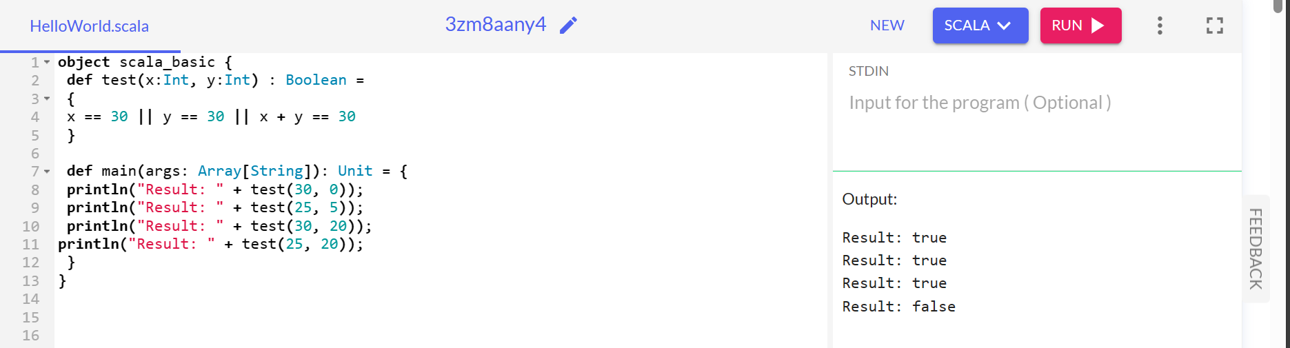

PROGRAM-2:

Write a Scala program that creates an abstract class Shape with an abstract method area. Implement subclasses Rectangle and Circle that override the area method.

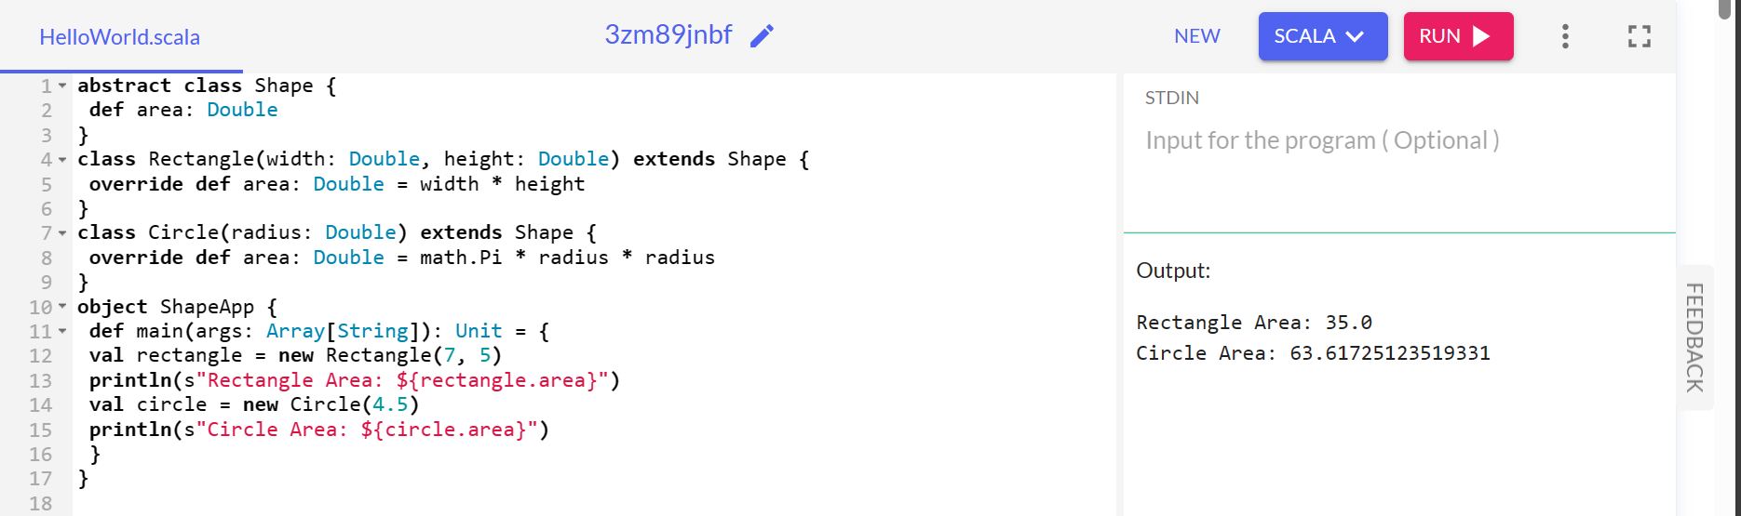

PROGRAM-3:

To check a given integer and return true if it is within 20 of 100 or 300:

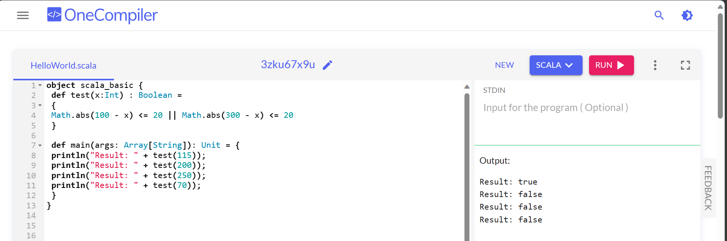

PROGRAM-4:

Find the greatest number between two numbers using Scala programming.

